pub sub teze
- event driven applications and microservices
- real time messaging service that allows you to send and recive messages between indepedent applications
- once an event is sucessfuly published as a message – it becomes a job of a service to ensure that all the systems that need to react on the event get it
- asynhronous integrations – reacts to events represented as a message
- event example in real world – order received, package shipped.. etc.
- push or pull
- service only need to emit event, wothout much care who gets it or receive event without much care how it got there
- service need to SUBSCRIBE to PUB/SUB and receiving right messages
- if any service break down, pub sub will store the messages for a few days or until the service comes back and deliver them
- IMPLEMENTATION:
- support publiher subscriber model
- publisher application creates and sends messages to a TOPIC which is a named resource
- the messages are stored until acknowlegded by all subscribers
- to receive this messages a subscriber app creates a subsription to a topic
- the subscriber recives a meesage by pub sub pushing them to the subcribers chosen endpoint or by subscriber pulling them from the service
- 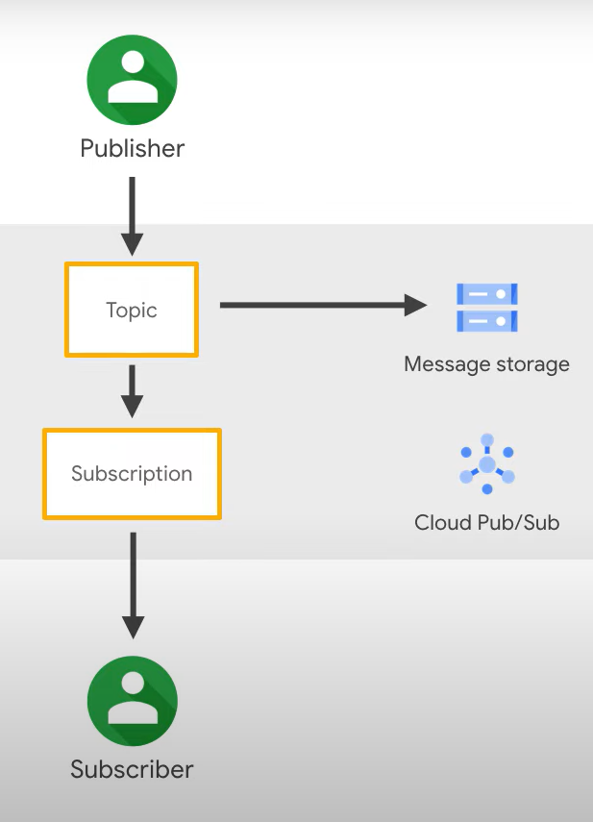
- when a message is aknolwledged by the subscriber it is removed from the subscription backlog??????? and not delevired again
- communication can be one to many – called FAN OUT
- communciation could be many to one – called FAN IN
- communication can be many to many

- MANY TO ONE MODEL– example: SUBSCRIBER X -> wants to receive a messages from 2 differnet publishers A and B – create two subscription corresponding to the topic for each publisher
- 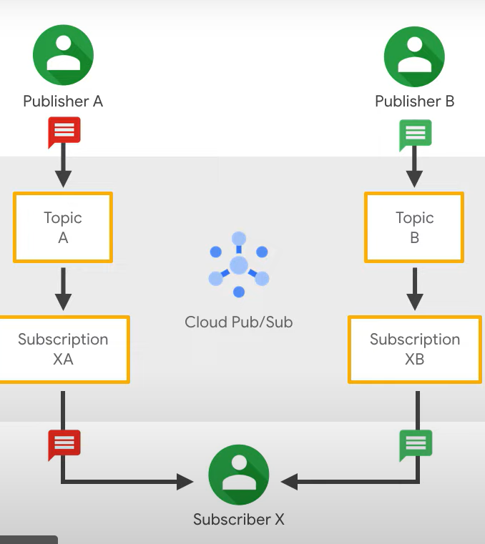
- ONE TO MANY MODEL – example, two diffeernet subscribers from one publisher – create two differnet subscriptions from THE SAME TOPIC
- 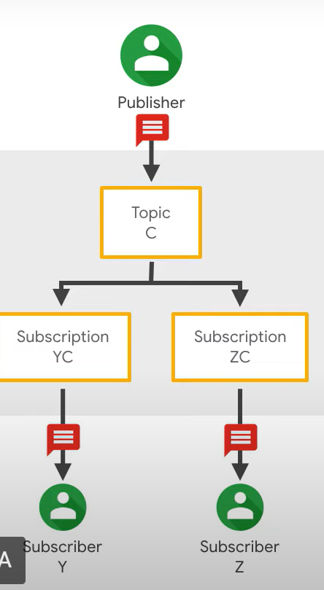

- Zadatak:

- napraviti pub/sub engine

- primer kroz twitter: tema npr Trump (neki topic ID je 5), ja se “pretplatim” (subscribe) na tu temu, neko objacu tu temu Trump odnodno objavljuje tu poruku za topic ID koji je 5, pozove se moj subscirber handler – i ja dobijem prouku za koju sam se pretplatila

- dve metode Subsctibe(int topic, string message) i Publish(int topic, string message)

- pub sub ima spisak topika i ima spisak subscribera

- nit koja se pretplacuje na temu npr 5 i posalji svima koji su pretplaceni na tu temu

- Delegat u c#
- pokazivac na funckiju
- koristi se da mogu da prosledim metodu kao argument da je sacuvam u promenljivoj ili da je pozovem kasnije
- Action – ugradjen delegat, nema paramatre
- Action<string> - metoda koja prima 1 string paramatar
- Action< int, string> - metoda koja prima 2 parametra

